Protocol for the Examination of Specimens from Patients with Carcinomas of the Perihilar Bile Ducts
Protocol applies to all invasive carcinomas of the perihilar bile ducts. Carcinomas of the distal extrahepatic bile ducts, intrahepatic bile ducts, and well differentiated neuroendocrine neoplasms (carcinoid tumors) are not included.

Based on AJCC/UICC TNM, 7th edition
Protocol web posting date: ____________
Protocol effective date: ____________

Procedures
• Local or Segmental Bile Duct Resection
• Hilar Resection with or without hepatic resection

Authors
Kay Washington, MD, PhD, FCAP*
Department of Pathology, Vanderbilt University Medical Center, Nashville, TN
Jordan Berlin, MD
Department of Medicine, Vanderbilt University Medical Center, Nashville, TN
Philip Branton, MD, FCAP
Department of Pathology, Inova Fairfax Hospital, Falls Church, VA
Lawrence J. Burgart, MD, FCAP
Allina Laboratories, Abbott Northwestern Hospital, Minneapolis, MN
David K. Carter, MD, FCAP
Department of Pathology, St. Mary’s/Duluth Clinic Health System, Duluth, MN
Carolyn C. Compton, MD, PhD, FCAP
Office of Biorepositories and Biospecimen Research, National Cancer Institute, Bethesda, MD
Patrick Fitzgibbons, MD, FCAP
Department of Pathology, St. Jude Medical Center, Fullerton, CA
Wendy L. Frankel, MD, FCAP
Department of Pathology, Ohio State University Medical Center, Columbus, OH
John Jessup, MD
Division of Cancer Treatment and Diagnosis, National Cancer Institute, Bethesda, MD
Sanjay Kakar, MD, FCAP
Department of Pathology, University of California San Francisco and the Veterans Affairs Medical Center, San Francisco, CA
Bruce Minsky, MD
Department of Radiation Oncology, University of Chicago, Chicago, IL
Raouf Nakhleh, MD, FCAP
Department of Pathology, Mayo Clinic, Jacksonville, FL
Jean-Nicolas Vauthey, MD†
Department of Surgical Oncology, University of Texas MD Anderson Cancer Center, Houston, TX

*denotes the primary author. † denotes the senior author. All other contributing authors are listed alphabetically.

For the Members of the Cancer Committee, College of American Pathologists

Previous contributors: Jorge Albores-Saavedra, MD; Donald E. Henson, MD

Surgical Pathology Cancer Case Summary (Checklist)

Protocol web posting date: ____________
Protocol effective date: ____________

PERIHILAR BILE DUCTS: Local or Segmental Resection, Hilar Resection with or without Hepatic Resection (Note A)

Select a single response unless otherwise indicated.

Specimen (select all that apply)
___ Common bile duct
___ Right hepatic duct
___ Left hepatic duct
___ Junction of right and left hepatic ducts
___ Common hepatic duct
___ Cystic duct

Other organs received:
___ Liver
___ Gallbladder
___ Other (specify): __________________________________

Procedure
___ Hilar and hepatic resection
___ Segmental resection of bile ducts(s)
___ Choledochal cyst resection (Note B)
___Total hepatectomy
___ Other (specify): ____________________________
___ Not specified

Tumor Site (select all that apply)
___ Right hepatic duct
___ Left hepatic duct
___ Junction of right and left hepatic ducts
___ Cystic duct
___ Common hepatic duct
___ Common bile duct
___ Not specified

Tumor Size
Greatest dimension: ___ cm
*Additional dimensions: ___ x ___ cm
___ Cannot be determined (see Comment)

Histologic Type (Note C)
___ Adenocarcinoma (not otherwise characterized)
___ Papillary adenocarcinoma
___ Mucinous adenocarcinoma
___ Clear cell adenocarcinoma
___ Signet-ring cell carcinoma
___ Adenosquamous carcinoma
___ Squamous cell carcinoma
___ Small cell carcinoma
___ Biliary cystadenocarcinoma
___ Other (specify): ____________________________
___ Carcinoma, not otherwise specified

Histologic Grade (Note D)
___ Not applicable
___ GX: Cannot be assessed
___ G1: Well differentiated
___ G2: Moderately differentiated
___ G3: Poorly differentiated
___ G4: Undifferentiated

Microscopic Tumor Extension (select all that apply)
___ Carcinoma in situ
___ Tumor confined to the bile duct histologically
___ Tumor invades beyond the wall of the bile duct into surrounding connective tissue
___ Tumor invades the adjacent liver parenchyma
___ Tumor invades the gallbladder
___ Tumor invades the unilateral branches of the portal vein (right or left)
___ Tumor invades the unilateral branches of the hepatic artery (right or left)
___ Tumor invades main portal vein or its branches bilaterally
___ Tumor invades common hepatic artery ________________________
___ Tumor invades second-order biliary radicals
___Unilateral
___Bilateral

Margins (select all that apply) (Note E)
Segmental Resection Specimen
___ Cannot be assessed
___ Margins uninvolved by invasive carcinoma
Distance of invasive carcinoma from closest margin: ___ mm OR ___ cm
Specify margin: __________________________
___ Margins involved by invasive carcinoma
___ Proximal bile duct margin
___ Distal bile duct margin
___ Hepatic parenchymal margin
___ Other (specify): _____________________________
___ Dysplasia/carcinoma in situ not identified at bile duct margin
___ Dysplasia/carcinoma in situ present at bile duct margin

Lymph-Vascular Invasion (Note F)
___ Not identified
___ Present
___ Indeterminate

Perineural Invasion (Note F)
___ Not identified
___ Present
___ Indeterminate

Pathologic Staging (pTNM) (Note G)

TNM Descriptors (Required only if applicable) (Select all that apply)
___ m (multiple primary tumors)
___ r (recurrent)
___ y (post-treatment)

Primary Tumor (pT)
___ pTX: Cannot be assessed
___ pT0: No evidence of primary tumor
___ pTis: Carcinoma in situ
___pT1: Tumor confined to the bile duct, with extension up to the muscle layer or fibrous tissue
___pT2a: Tumor invades beyond the wall of the bile duct to surrounding adipose tissue
___pT2b: Tumor invades adjacent hepatic parenchyma
___pT3: Tumor invades unilateral branches of the portal vein or hepatic artery
___pT4: Tumor invades main portal vein or its branches bilaterally; or the common hepatic artery; or the second-order biliary radicals bilaterally; or unilateral second-order biliary radicals with contralateral portal vein or hepatic artery involvement

Regional Lymph Nodes (pN)
___ pNX: Cannot be assessed
___ pN0: No regional lymph node metastasis
___ pN1: Regional lymph node metastasis (including nodes along the cystic duct, common bile duct, hepatic artery, and portal vein)
___pN2: Metastasis to periaortic, pericaval, superior mesentery artery, and/or celiac artery lymph nodes
Specify: Number examined ___
Number involved ___

Distant Metastasis (pM)
___ Cannot be assessed
___ pM1: Distant metastasis
*Specify site(s), if known: _________________________

*Additional Pathologic Findings (select all that apply) (Note H)
*___ None identified
*___ Choledochal cyst
*___ Dysplasia
*___ Primary sclerosing cholangitis
*___ Biliary stones
*___ Other (specify): ___________________________

*Ancillary Studies
*Specify: ___________________________________

Clinical History
____ Primary sclerosing cholangitis
____ Inflammatory bowel disease
____ Biliary stones
____ Other (specify): ______________________________
____ Not known

*Comment(s)

Explanatory Notes

A. Application
Tumors arising in the biliary tree are classified into three groups: intrahepatic, perihilar, and distal. Perihilar tumors are defined as those involving the hepatic duct bifurcation or extrahepatic biliary tree proximal to the origin of the cystic duct ¹; distal tumors are defined as those arising between the junction of the cystic duct-bile duct and the Ampulla of Vater². This protocol applies only to perihilar carcinomas. It does not include tumors of the extrahepatic bile ducts that arise distal to the cystic duct, low grade neuroendocrine neoplasms (carcinoids) or tumors arising in the ampulla of Vater. Carcinomas arising in the cystic duct are grouped for staging purposes with carcinomas of the gallbladder (see Protocol for Examination of Specimens with Carcinomas of the Gallbladder). Tumors arising within the intrahepatic bile ducts are classified and staged as carcinomas of the intrahepatic bile ducts (see Protocol for Examination of Specimens with Carcinomas of the Intrahepatic Bile Ducts). Carcinomas arising in the middle portion of the extrahepatic bile duct are classified according to their treatment (combined hepatic and hilar resection for perihilar tumors, pancreaticoduodenectomy for distal bile duct tumors).

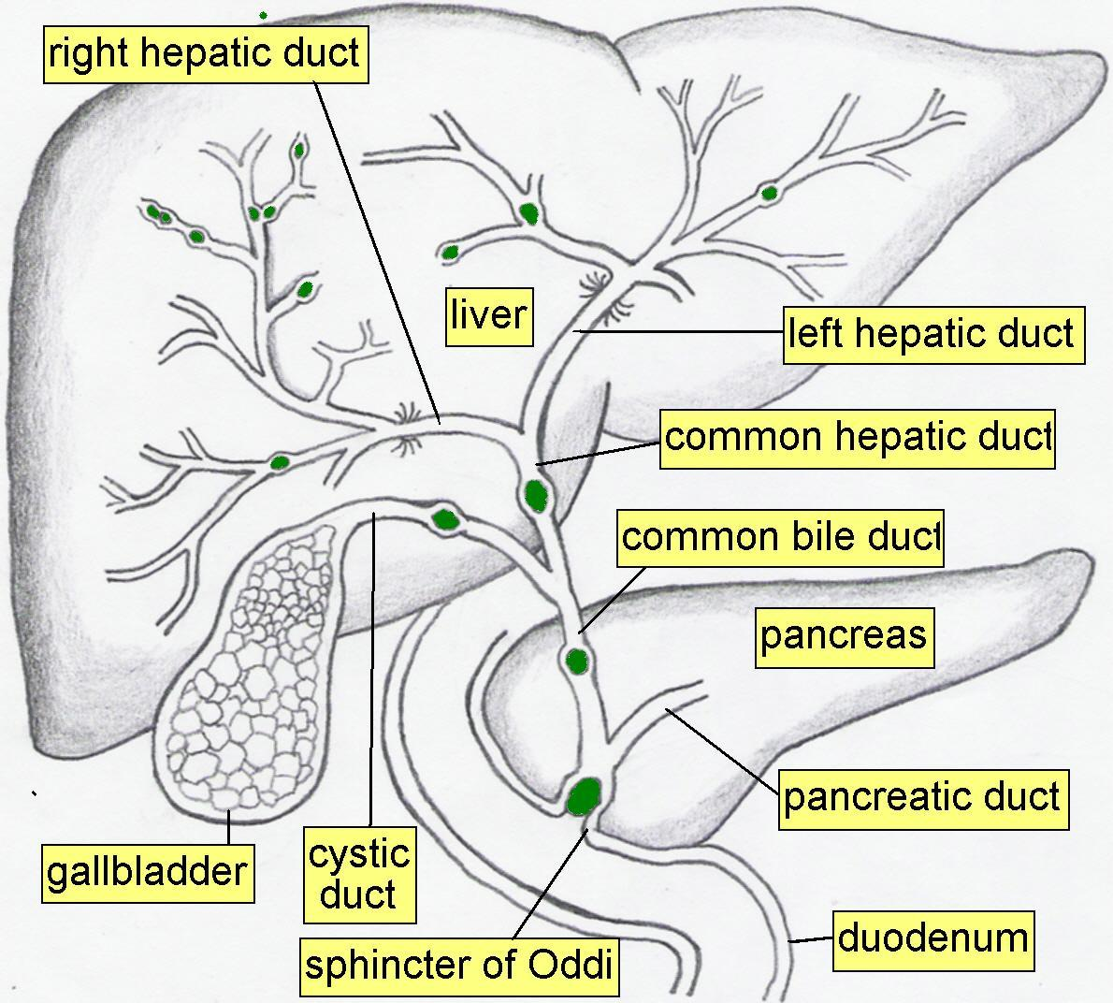

Figure 1. Anatomy of the biliary system.

B. Choledochal Cyst
Carcinomas may arise in choledochal cysts (congenital cystic dilatation or duplications) of the bile duct. Histologically, they are classified in the same way as those arising in the gallbladder or bile ducts. Stones may be found in these cysts. If dysplasia or carcinoma in situ is found on initial microscopic sections, then multiple additional sections should be examined to exclude invasive cancer in other areas of the cyst.

C. Histologic Type
For consistency in reporting, the histologic classification published by the World Health Organization (WHO), shown below, is recommended ³. However, this protocol does not preclude the use of other systems of classification or histologic types. By WHO convention, the term “cholangiocarcinoma” is reserved for carcinomas arising in the intrahepatic bile ducts (see Intrahepatic Bile Ducts protocol).

Some histologic types of bile duct carcinoma are prognostically significant; papillary carcinomas, which are often polypoid on macroscopic examination have the best prognosis ⁴,⁵. High-grade tumors such as signet-ring cell carcinomas, small cell carcinomas, and undifferentiated carcinomas are associated with a poorer prognosis compared to adenocarcinoma. Many of the special subtypes, such as clear cell adenocarcinoma, are rarely encountered. The following classification is adapted from the WHO classification of carcinoma of the extrahepatic bile ducts:

Modified WHO Classification of Carcinoma of the Extrahepatic Bile Ducts
Adenocarcinoma
Papillary adenocarcinoma#
Adenocarcinoma, intestinal type
Mucinous adenocarcinoma
Clear cell adenocarcinoma#
Signet-ring cell carcinoma##
Adenosquamous carcinoma
Squamous cell carcinoma
Small cell carcinoma###
Large cell neuroendocrine carcinoma
Undifferentiated carcinoma###
Biliary cystadenocarcinoma

# These histologic types are not usually graded.

## By convention, signet-ring cell carcinomas are assigned grade 3 (see below).

### Small cell carcinomas and undifferentiated (histologic type) carcinomas are assigned grade 4 (see below).

D. Histologic Grade
For adenocarcinomas, a quantitative grading system based on the proportion of gland formation within the tumor is suggested ³ and shown below.

Grade X Grade cannot be assessed
Grade 1 Well differentiated (greater than 95% of tumor composed of glands)
Grade 2 Moderately differentiated (50% to 95% of tumor composed of glands)
Grade 3 Poorly differentiated (less than 50% of tumor composed of glands)

Definitions corresponding to the above histologic grades are as follows.

Grade 1 Composed entirely of glands or has less than 5% solid or cord-like growth patterns
Grade 2 Has more than 5% but less than 50% solid or cord-like growth patterns
Grade 3 Has 50% to 100% solid or cord-like growth patterns

For squamous cell carcinomas, a rare tumor type in the extrahepatic bile ducts, a suggested grading system is shown below. If there are variations in the differentiation within the tumor, the highest (least favorable) grade is recorded.

Grade X Grade cannot be assessed
Grade 1 Well differentiated
Grade 2 Moderately differentiated
Grade 3 Poorly differentiated

Note: Tumors with no differentiation or minimal differentiation that is discernible only in rare tiny foci (undifferentiated carcinomas by WHO classification) are categorized as Grade 4.

E. Margins
Locoregional recurrence, as opposed to distant metastases, is usually the first site of disease recurrence, and occurs in up to 59% of patients with perihilar bile duct carcinomas⁶. Tumor recurrence is often related to residual tumor located in the proximal or distal surgical margins of the bile duct or from tumor located along the dissected soft tissue margin in the portal area. Local recurrence (usually at the surgical margins) can be attributed in many cases to tumor spread longitudinally along the duct wall and to perineural and lymphovascular invasion ⁷.

Complete surgical resection with microscopically negative surgical margins is an important predictor of outcome in multivariate analysis for both perihilar and distal bile duct carcinomas, with overall five year survival for perihilar tumor improved from 10% for all patients to 30% for those with negative resection margins¹.

Malignant tumors of the extrahepatic bile ducts are often multifocal ⁸. Therefore, microscopic foci of carcinoma or intraepithelial neoplasia may be found at the margin(s) even though the main tumor mass has been resected. In some cases it may be difficult to evaluate margins on frozen section preparations because of inflammation and reactive change of the surface epithelium or within the intramural mucous glands. If surgical margins are free of carcinoma, the distance between the closest margin and the tumor edge should be measured.

Since 5% of patients with bile duct carcinoma have synchronous carcinomas of the gallbladder, examination of the entire surgical specimen including the gallbladder is advised.

F. Perineural and Vascular/Lymphatic Invasion
Perineural and lymphatic invasion are common in extrahepatic bile duct carcinomas, although they are found less often in early stage cancers (11%) ⁹. They should be specifically evaluated since they are associated with adverse outcome ¹⁰ on univariate analysis. While perineural invasion is sometimes useful for distinguishing carcinoma from non-neoplastic glands, caution should be used in interpretation of this finding in ducts affected by primary sclerosing cholangitis, as perineural invasion by benign hyperplastic intramural glands as been reported in this setting ¹¹ and may be seen in adenomatous hyperplasia.

G. TNM and Stage Groupings

Surgical resection is the most effective therapy for extrahepatic biliary tract carcinomas, and the best estimation of prognosis is related to the anatomic extent (stage) of disease at the time of resection. In particular, lymph node metastases are predictors of poorer outcome ^{1, 12}.

The TNM staging system for malignant tumors of the perihilar bile ducts of the American Joint Committee on Cancer (AJCC) and the International Union Against Cancer (UICC) is recommended and shown below ². The staging system also applies to tumors arising in choledochal cysts.

By AJCC/UICC convention, the designation “T” refers to a primary tumor that has not been previously treated. The symbol “p” refers to the pathologic classification of the TNM, as opposed to the clinical classification, and is based on gross and microscopic examination. pT entails a resection of the primary tumor or biopsy adequate to evaluate the highest pT category, pN entails removal of nodes adequate to validate lymph node metastasis, and pM implies microscopic examination of distant lesions. Clinical classification (cTNM) is usually carried out by the referring physician before treatment during initial evaluation of the patient or when pathologic classification is not possible.

Pathologic staging is usually performed after surgical resection of the primary tumor. Pathologic staging depends on pathologic documentation of the anatomic extent of disease, whether or not the primary tumor has been completely removed. If a biopsied tumor is not resected for any reason (eg, when technically unfeasible) and if the highest T and N categories or the M1 category of the tumor can be confirmed microscopically, the criteria for pathologic classification and staging have been satisfied without total removal of the primary cancer.

TNM Descriptors
For identification of special cases of TNM or pTNM classifications, the “m” suffix and “y,” “r,” and “a” prefixes are used. Although they do not affect the stage grouping, they indicate cases needing separate analysis.

The “m” suffix indicates the presence of multiple primary tumors in a single site and is recorded in parentheses: pT(m)NM.

The “y” prefix indicates those cases in which classification is performed during or following initial multimodality therapy (ie, neoadjuvant chemotherapy, radiation therapy, or both chemotherapy and radiation therapy). The cTNM or pTNM category is identified by a “y” prefix. The ycTNM or ypTNM categorizes the extent of tumor actually present at the time of that examination. The “y” categorization is not an estimate of tumor prior to multimodality therapy (ie, before initiation of neoadjuvant therapy).

The “r” prefix indicates a recurrent tumor when staged after a documented disease-free interval, and is identified by the “r” prefix: rTNM.

The “a” prefix designates the stage determined at autopsy: aTNM.

T Category Considerations
pTis. For bile duct carcinomas, "carcinoma in situ" (pTis) as a staging term includes neoplastic cells cytologically indistinguishable from invasive carcinoma but confined within the glandular basement membrane ⁸. Separation of high-grade dysplasia from carcinoma in situ is subjective and because morphologic criteria are ill-defined, subject to interobserver variability. The term “carcinoma in situ” is not widely applied to glandular neoplastic lesions in the gastrointestinal tract but is retained for tumor registry reporting purposes as specified by law in many states. Non-invasive bile duct carcinomas with a papillary growth pattern are classified as pTis.

pT2 and pT3 (Figures 2 and 3). Because the histology of the extrahepatic biliary tree varies along its length, with little smooth muscle in the wall of the proximal ducts compared to the distal bile duct, assessment of depth of tumor invasion may be difficult. In addition to the problem caused by lack of discrete tissue boundaries, inflammatory changes in the bile ducts and desmoplastic stromal response to tumor may cause distortion. To overcome these difficulties, it has been proposed that the pathologist should measure the depth of invasion of tumor from the basal lamina of normal epithelium to the point of deepest tumor invasion ¹³. However, this system has not yet been widely adopted for staging purposes.

Vessel Invasion
By AJCC/UICC convention, vessel invasion (lymphatic or venous) does not affect the T category indicating local extent of tumor unless specifically included in the definition of a T category.

N Category Considerations

The regional nodes for perihilar bile duct carcinomas are hilar nodes along the cystic duct, common bile duct, hepatic artery, and portal vein (N1), and periaortic, pericaval, superior mesentery artery, and/or celiac artery lymph nodes (N2).

Tumor involvement of other nodal groups is considered distant metastasis. Anatomic division of regional lymph nodes is not necessary, but separately submitted lymph nodes should be reported as submitted.

Routine assessment of regional lymph nodes is limited to conventional pathologic techniques (gross assessment and histologic examination) and data are currently insufficient to recommend special measures to detect micrometastasis or isolated tumor cells. Thus, neither multiple levels of paraffin blocks nor the use of special/ancillary techniques such as immunohistochemistry are recommended for routine examination of regional lymph nodes.

Primary Tumor (T)
TX Primary tumor cannot be assessed
T0 No evidence of primary tumor
Tis Carcinoma in situ
T1 Tumor confined to the bile duct, with extension up to the muscle layer or fibrous tissue
T2a Tumor invades beyond the wall of the bile duct to surrounding adipose tissue
T2b Tumor invades adjacent hepatic parenchyma
T3 Tumor invades unilateral branches of the portal vein or hepatic artery
T4 Tumor invades main portal vein or its branches bilaterally; or the common hepatic artery; or the second-order biliary radicals bilaterally; or unilateral second-order biliary radicals with contralateral portal vein or hepatic artery involvement

Regional Lymph Nodes (N)
NX: Cannot be assessed
N0: No regional lymph node metastasis
pN1: Regional lymph node metastasis (including nodes along the cystic duct, common bile duct, hepatic artery, and portal vein)
pN2: Metastasis to periaortic, pericaval, superior mesentery artery, and/or celiac artery lymph nodes

Distant Metastasis (M)
MX Distant metastasis cannot be assessed
M0 No distant metastasis
M1 Distant metastasis

Stage Groupings
Stage 0 Tis N0 M0
Stage I T1 N0 M0
Stage II T2a or T2b N0 M0
Stage IIIA T3 N0 M0
Stage IIIB T1, T2, or T3 N1 M0
Stage IVA T4 N0 or N1 M0
Stage IVB Any T N2 M0 or M1
Any T Any N M1

H. Additional Findings
Chronic inflammatory conditions affecting the bile ducts are associated with higher risk for biliary tract carcinomas. The most common risk factor for cholangiocarcinoma of the extrahepatic bile ducts in Western countries is primary sclerosing cholangitis (PSC), characterized by multifocal strictures and inflammation of the extra- and intrahepatic biliary tree. Patients with PSC are at risk for multifocal biliary carcinomas. In Japan and Southeast Asia, hepatolithiasis due to recurrent pyogenic cholangitis with biliary stones is a more common risk factor for biliary malignancy. Biliary parasites such as Clonorchis sinensis and Opisthoorchis viverrini, prevalent in parts of Asia, are also associated with carcinomas of the extrahepatic bile ducts.

References

1. DeOliveira ML, Cunningham SC, Cameron JL et al. Cholangiocarcinoma: thirty-one-year experience with 564 patients at a single institution. Annals of Surgery 2007;245:755-762.
2. Edge S. AJCC Staging Manual. 7th ed. New York: Springer-Verlag; 2009.
3. Albores-Saavedra J, Scoazec JC, Wittekind C et al. Tumours of the gallbladder and extrahepatic bile ducts. In: Hamilton SR, Aaltonen LA, eds. World Health Organization Classification of Tumours. Pathology and Genetics of Tumours of the Digestive System. Lyon: IARC Press; 2000:203-218.
4. Albores-Saavedra J, Murakata L, Krueger JE, Henson DE. Noninvasive and minimally invasive papillary carcinomas of the extrahepatic bile ducts. Cancer. 2000;89:508-15.
5. Jarnagin WR, Bowne W, Klimstra DS et al. Papillary phenotype confers improved survival after resection of hilar cholangiocarcinoma. Annals of Surgery 2005;241:703-712.
6. Jarnagin WR, Ruo L, Little SA et al. Patterns of initial disease recurrence after resection of gallbladder carcinoma and hilar cholangiocarcinoma: implications for adjuvant therapeutic strategies. Cancer. 2003;98:1689-700.
7. Jarnagin WR. Cholangiocarcinoma of the extrahepatic bile ducts. Seminars in Surgical Oncology. 2000;19:156-176.
8. Albores-Saavedra J, Henson DE, Klimstra DS. Tumors of the Gallbladder, Extrahepatic Bile Duct, and Ampulla of Vater. Fascicle 27 vol. Third Series ed. Washington, D. C.: Armed Forces Institute of Pathology; 2000.
9. Cha JM, Kim MH, Lee SK et al. Clinicopathological review of 61 patients with early bile duct cancer. Clinical 2006;Oncology:669-77.
10. Murakami Y, Uemura K, Hayashidani Y, Sudo T, Ohge H, Sueda T. Pancreatoduodenectomy for distal cholangiocarcinoma: prognostic impact of lymph node metastasis. World Journal of Surgery. 2007;31:337-42; discussion 343-4.
11. Katabi N, Albores-Saavedra J. The extrahepatic bile duct lesions in end-stage primary sclerosing cholangitis.[see comment]. American Journal of Surgical Pathology. 2003;27:349-55.
12. Hong SM, Cho H, Lee OJ, Ro JY. The number of metastatic lymph nodes in extrahepatic bile duct carcinoma as a prognostic factor.[erratum appears in Am J Surg Pathol. 2005 Nov;29(11):1548]. American Journal of Surgical Pathology. 2005;29:1177-83.
13. Hong SM, Cho H, Moskaluk CA, Yu E. Measurement of the invasion depth of extrahepatic bile duct carcinoma: An alternative method overcoming the current T classification problems of the AJCC staging system. American Journal of Surgical Pathology. 2007;31:199-206.

Figure Legends.

Figure 1. Anatomy of the biliary system.
Figure 2. T1 tumors are confined to the bile duct histologically. (16.2)
Figure 3. T2 tumors invade beyond the wall of the bile duct. (16.3)

